Health Research Council of New Zealand

Pulmonary Model-based Decision Support to Optimise ARDS/ ALI Care (PulMoDS)

Data Monitoring Committee Close Statistical Report:

No. XX, Date: XX/ MM/ YYYY
Sample: All values, dates, figures and tables are generated using MATLAB (R2014a, The Mathworks, Natick, Massachusetts, USA) for illustration purpose only

Contents
1. | Introduction | 3
2. | Baseline Variables | 4
3. | Outcome Measurements | 7

List of Figures
1. | Figure 1: Baseline values (Empirical cumulative plots) for patients included in the trial. Blue is Control and Red is Intervention. a) Age, b) Estimated Height, c) Estimated Weight, d) PF ratio at the time of randomisation and, e) SPO₂ at the time of randomisation. | 4
2. | Figure 2: Mechanical ventilation data (Empirical cumulative plots) for patients included in the trial. Blue is Control and Red is Intervention. a) Normalised PEEP settings, b) Normalised FiO₂ settings, c) Normalised Maximum PIP and, d) Normalised tidal volume. | 5
3. | Figure 3: Outcome measurements (Empirical cumulative plots) for patients included in the trial. Blue is Control and Red is Intervention. a) PF ratio normalised, b) SPO₂ normalised, c) length of Mechanical ventilation, d) Ventilator free days and, e) number of desaturation events. | 7

List of Tables
1. | Table 1: Summary of baseline values. | 6
2. | Table 2: Summary of mechanical ventilation settings | 6
3. | Table 3: Summary of outcome measurements | 8
1.0 Introduction
The following is the Pulmonary Model-based Decision Support to Optimise ARDS/ ALI Care (PulMoDS) Close Statistic Report for Data Monitoring Committee, on the data gathered till 31/ 12/ 2000. The report was generated on 31/ 01/ 2001. Clinical trial statistical analysis is performed using MATLAB (R2014a, The Mathworks, Natick, MA, USA).

2.0 Baseline Variables
a) | 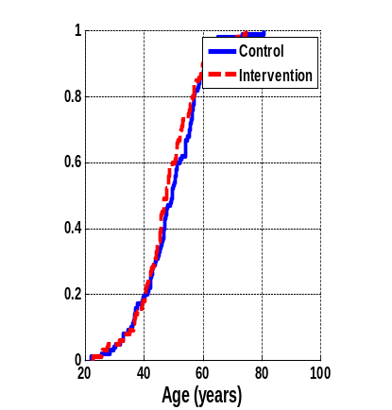 | b) | 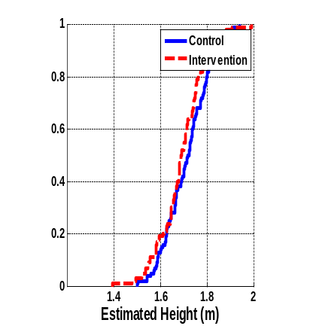
c) | 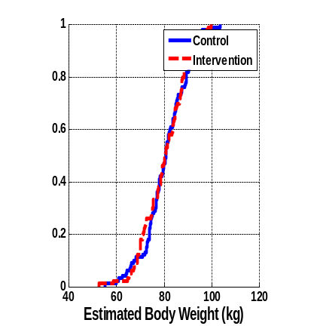 | d) | 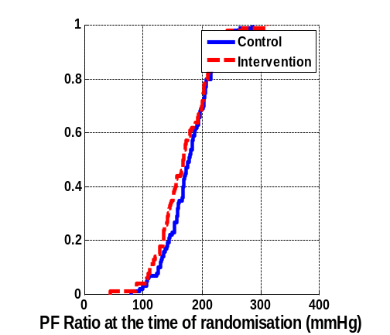
e) | 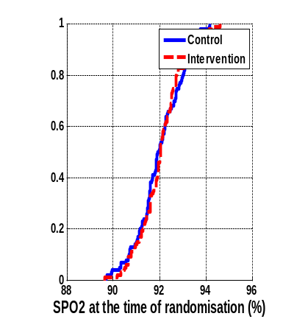

Figure 1: Baseline values (Empirical cumulative plots) for patients included in the trial. Blue is Control and Red is Intervention. a) Age, b) Estimated Height, c) Estimated Weight, d) PF ratio at the time of randomisation and, e) SPO₂ at the time of randomisation.

a) | 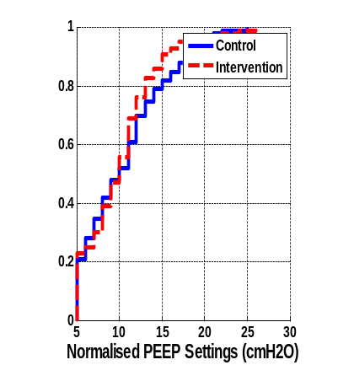 | b) | 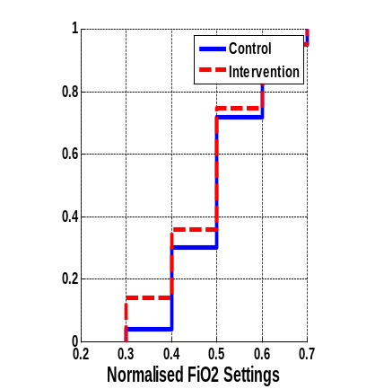
c) | 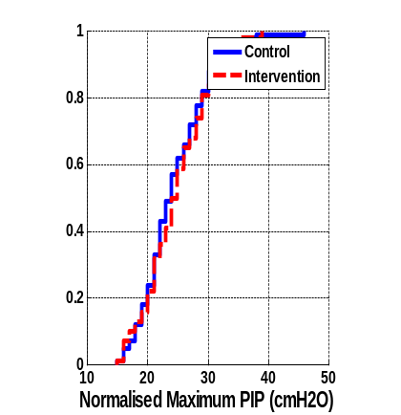 | d) | 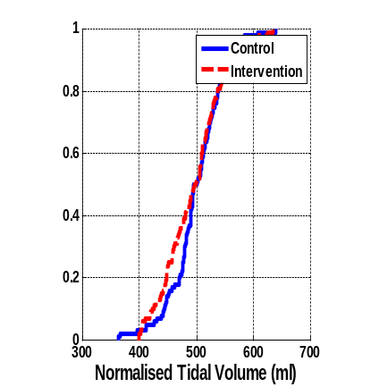

Figure 2: Mechanical ventilation data (Empirical cumulative plots) for patients included in the trial. Blue is Control and Red is Intervention. a) Normalised PEEP settings, b) Normalised FiO₂ settings, c) Normalised Maximum PIP and, d) Normalised tidal volume.

Table 1: Summary of Baseline values.

Description | Patient Group
Baseline Values | Control | Intervention | p-value
 | Mean ± SD  Median [IQR] | Mean ± SD  Median [IQR]
Age
Sex (Male)
Height (estimated)
Weight (estimated)
PF Ratio (on randomisation)
SPO₂ (on randomisation)
* Note
- Every baseline value distribution is assessed using Kolmogorov-Smirnov test.
- Values are displayed in median [interquartile range].
- Non parametric statistical analysis is performed using Wilcoxon ranksum test
- Parameter statistical analysis is performed using Student t-test

Table 2: Summary of mechanical ventilation settings

Description | Patient Group
Baseline Values | Control | Intervention | p-value
 | Mean ± SD  Median [IQR] | Mean ± SD  Median [IQR]
PEEP (cmH₂O)
PIP (cmH₂O)
FiO₂ (%)
Vt (ml)
* Note
- Baseline value distribution is assessed using Kolmogorov-Smirnov test.
- Values are displayed in median [interquartile range].
- Non parametric statistical analysis is performed using Wilcoxon ranksum test
- Parameter statistical analysis is performed using Student t-test

3.0 Outcome Measurements
a) | 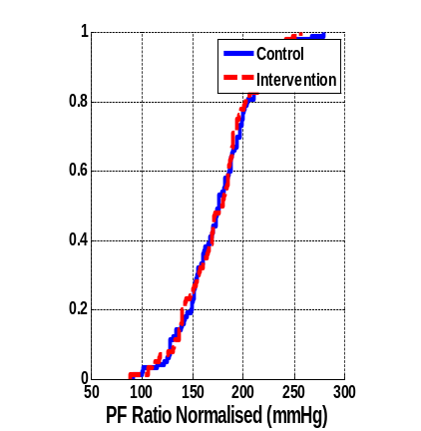 | b) | 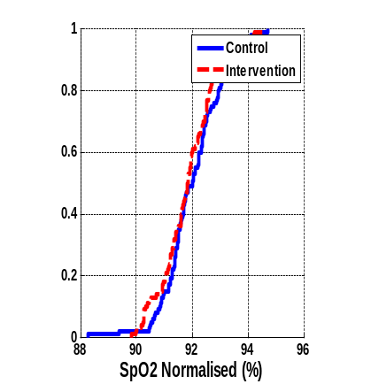
c) | 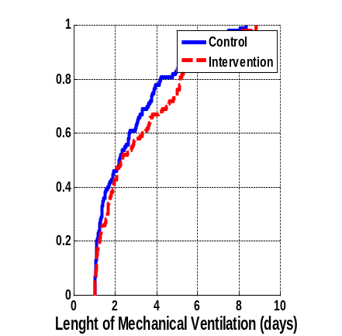 | d) | 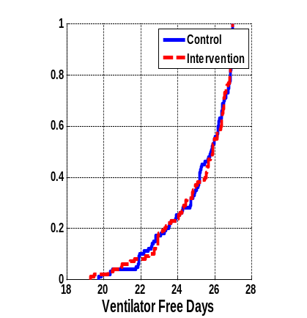
e) | 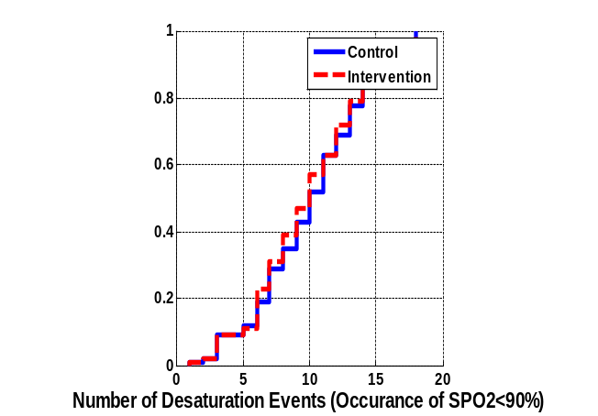

Figure 3: Outcome measurements (Empirical cumulative plots) for patients included in the trial. Blue is Control and Red is Intervention. a) PF ratio normalised, b) SPO₂ normalised, c) length of Mechanical ventilation, d) Ventilator free days and, e) number of desaturation events.

Table 3: Summary of outcome measurements

Description | Patient Group
 | Control | Intervention | p-value
 | Mean ± SD  Median [IQR] | Mean ± SD  Median [IQR]
PF Ratio (mmHg)
SPO₂ (%)
LoMV (days)
VFD (days)
Number of desaturation events (#)
* Note
- Baseline value distribution is assessed using Kolmogorov-Smirnov test.
- Values are displayed in median [interquartile range].
- Non parametric statistical analysis is performed using Wilcoxon ranksum test
- Parameter statistical analysis is performed using Student t-test

